Exchange 2010 Architecture Report Tool

Authors

Franck NEROT [fnerot66@hotmail.com](mailto:fnerot66@hotmail.com)

Pascal THEIL [skall_21@hotmail.com](mailto:skall_21@hotmail.com)

If you have any comments or suggestion, do not hesitate.

1. **Requirements**

This script needs the following:

* Powershell V2
* Exchange 2010 Management Tools

1. **Summary**

This tool is aimed at providing information about an Exchange 2010 environment.

In this version, the script collects the following information:

* Active Directory
* Viewing SPNs
* Duplicated SPNs
* Hardware information
* Disk Report Information
* Exchange Servers Information
* Exchange Services
* Exchange Rollup (E2K7 only)
* Exchange Rollup (E2K10 Only)
* Client Access Server Information
* Client Access Server - OWA Virtual Directory
* Client Access Server - WebServices Virtual Directory
* Client Access Server - Autodiscover Virtual Directory
* Client Access Server - OAB Virtual Directory
* Client Access Server - ECP Virtual Directory
* Client Access Server - ActiveSync Virtual Directory
* Client Access Server - Powershell Virtual Directory
* Client Access Server - Exchange Certificates
* HUB Transport - Information
* HUB Transport - Back Pressure (E2K10 Only)
* Database Availability Group - Information
* Database Availability Group - Network
* Database Availability Group - Replication
* Database Availability Group - DatabaseCopy
* Database Availability Group - Backup
* Database Availability Group - Database Size and Availability
* Database Availability Group - RPCClientAccessServer
* Mailbox Server - Information
* Mailbox Server - Database Size and Availability
* Mailbox Server - Backup
* Mailbox Server - RPCClientAccessServer
* Mailbox Server - Offline Address Book
* Mailbox Server - Calendar Repair Assistant
* Public Folder Databases
* RPCClientAccess Information
* Test Mailflow
* Test OWA Connectivity
* Test Web Services Connectivity
* Test ActiveSync Connectivity
* Test ECP Connectivity
* Test MAPI Connectivity - Mailbox and Public Folder Databases
* Test OutlookConnectivity
* Test OutlookWebServices
* Test PowershellConnectivity

The output generated is an HTML File like the following one:

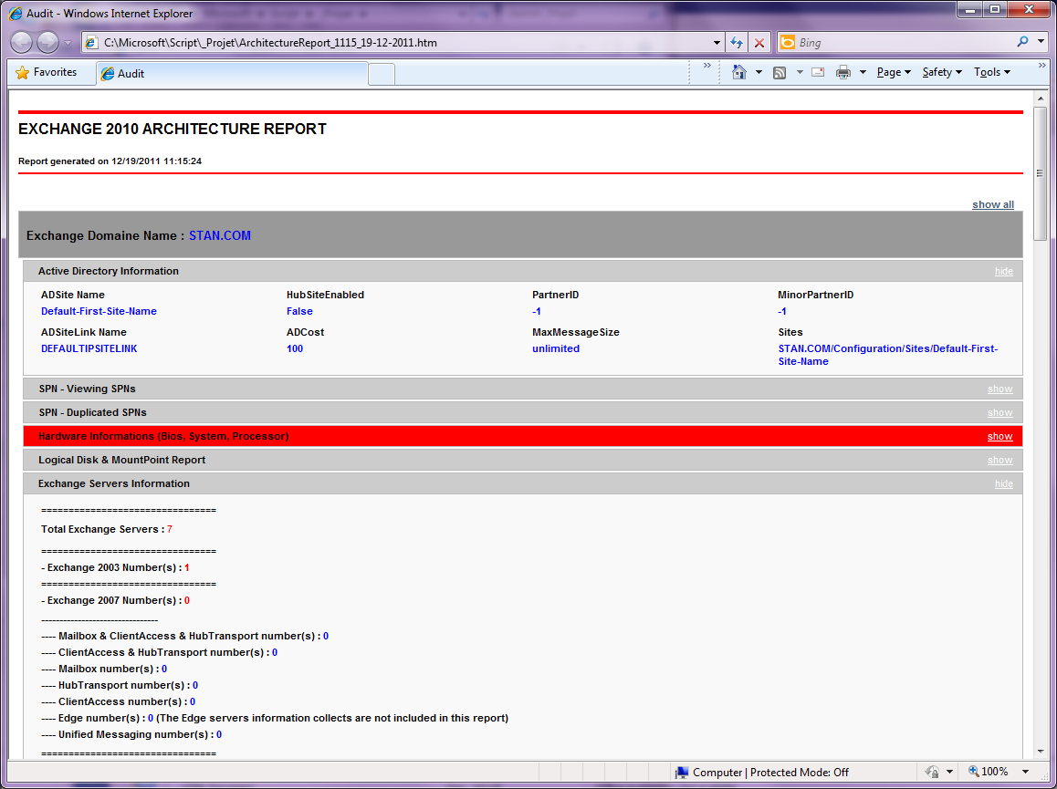

In order to generate this report, you can use either a graphical user interface and choose which type of checks you want to perform or a command line version. That way you can schedule a task to execute the script without being prompted by an interface.

1. **Graphic User Interface**

In order to launch this script, please run the file **“.\E2K10_Architecture_GUI_V2.ps1”**.

The Graphical User Interface is as the next screenshot.

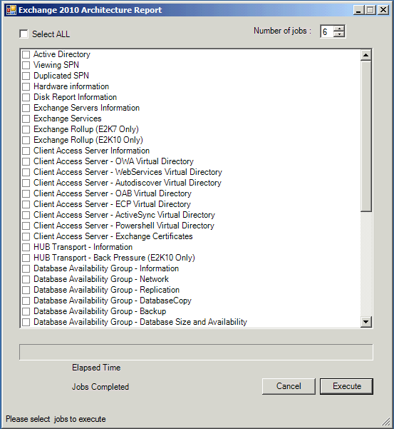

In this interface, you have several options:

1. Select All

By checking the “Select All” checkbox you can select or unselect all the checks

1. Number of jobs

The script creates one job for each check. To avoid creating decades of jobs, you can specify the limit of simultaneous jobs that will run at the same time. We did some tests and it appears that 6 is the best value, that’s also the default value. But you can select a value between 2 and 15.

1. Cancel Button

At any time during the script execution, you can cancel it.

1. Execute Button

When you have selected the options you want, clicking on “Execute” will launch the script execution.

1. Progress Bar and “Jobs Completed”

A progress bar and a “Jobs completed” section represent the execution of each script.

1. Status Bar

The Status Bar shows information about what the script is doing.

1. Elapsed Time

This Label shows how much time has elapsed since the script has started

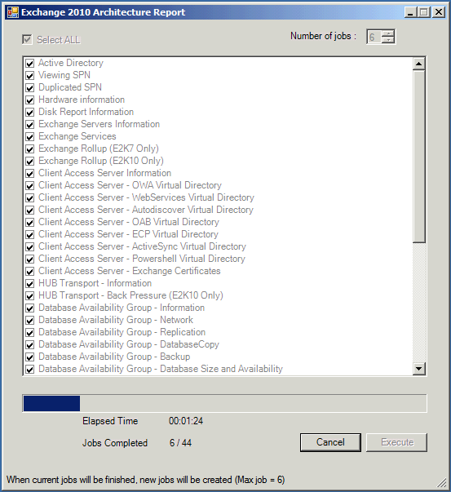

1. **Command-Line Version**

The first version of this script was only available as a command line version. We decided for this second version to introduce a GUI version to have the opportunity to select exactly what check you want to run. But we decided to keep also a command line version in case you plan to execute it through a task scheduler.

The only parameter needed for this version is the number of jobs limit. By default all the checks will be done.

In order to launch this script, please run the file **“.\E2K10_Architecture_CMD_V2.ps1 <JOBSMAX>”** where <JOBSMAX> is the maximum number of simultaneous jobs. The value must be between 2 and 15, but we recommend a value of 6.